Gedling Leisure Survey

About This Survey

Gedling Borough Council wants to improve leisure centres in the area.

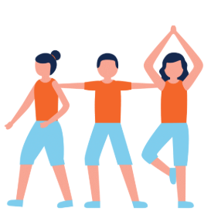
We want them to be bright, welcoming, and easy for everyone to use.

The centres should help people live healthier lives and be good for the environment.


We are working with two companies called Alliance Leisure and Active Insight to ask people what they think.

We want to know what people like, what they need, and what would make the centres better.
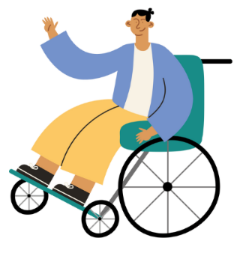
Some questions ask about accessibility (how easy it is for you to use the centres) and inclusion (if everyone feels welcome).

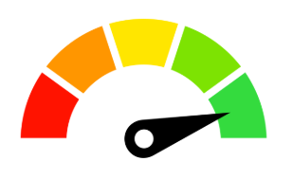
These questions help us make the centres better for everyone.

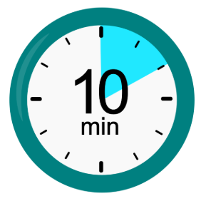
This survey is private and will take about 5-10 minutes to complete.


We are also holding small group chats (called focus groups) with some people who fill in this survey. If you say you are interested, we might contact you about this.


Your contact details will only be used for this project. They will be kept safe, following privacy rules.
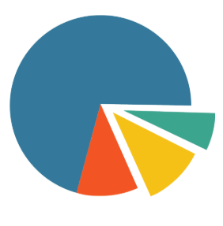

By filling in this survey, you agree that Active Insight may contact you about this project.
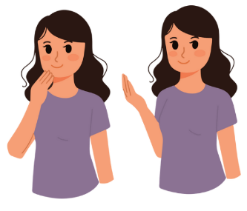

Thank you for your help in making Gedling’s leisure centres better.

1. By doing this survey, do you agree that Gedling Borough Council can use your personal details for this project (as explained above)?

☐ Yes
☐ No

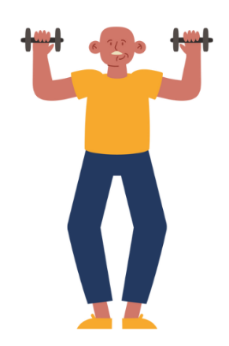
2. Do you use any Gedling Borough Council leisure centres? If you answer no, please go straight to Question 26.

☐ Yes
☐ No

3. Which ones do you use? (Tick all that apply)

☐ Carlton Forum Leisure Centre
☐ Redhill Leisure Centre
☐ Calverton Leisure Centre
☐ Arnold Leisure Centre
☐ Richard Herrod Centre


4. Do you live in Gedling Borough?

☐ Yes
☐ No

5. How often do you go to a leisure centre?

☐ Less than once a week
☐ Once a week
☐ Twice a week
☐ Three times a week
☐ More than three times a week

6. How long does it usually take you to get to a leisure centre?
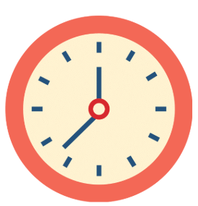
☐ Less than 5 minutes
☐ 5-10 minutes
☐ 10-15 minutes
☐ 15-20 minutes
☐ 20-25 minutes
☐ 25-30 minutes
☐ More than 30 minutes
7. How long would you be willing to travel to a leisure centre?

☐ Less than 5 minutes
☐ 5-10 minutes
☐ 10-15 minutes
☐15-20 minutes
☐ 20-25 minutes
☐ 25-30 minutes
☐ More than 30 minutes

8. How do you usually get to the leisure centre?

☐ Walk
☐ Cycle
☐ Bus, train or other public transport
☐ Car
☐ Other (please say)
…………………………………………………………………………
…………………………………………………………………………

9. What things do you use at the leisure centre? (Tick all that you use)

☐ Main Pool
☐ Learner Pool
☐ Gym
☐ Exercise Classes
☐ Sports Hall
☐ Sauna/Steam room
☐ Outdoor pitches (fields for sport)
☐ Sports Club
☐ Squash Courts
☐ Community Space (a room for people to meet and do activities)
☐ Event Space (a place for parties or big events)
☐ Bowls Club
☐ Other (please say)
…………………………………………………………………………
…………………………………………………………………………

10. Is there anything that makes it hard for you to use the leisure centre? (Tick all that apply)
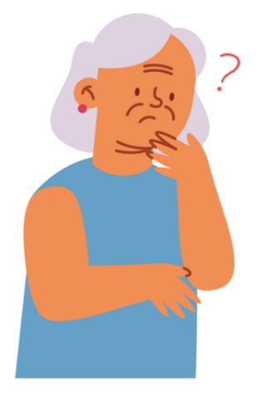
☐ Stairs
☐ Ramps
☐ Lifts
☐ Railings (handrails)
☐ Parking
☐ Pool access (getting into the swimming pool)
☐ Signage (signs that tell you where things are)
☐ Nothing stops me
☐ Other (please say)


11. What do you think of our leisure centres?

☐ Very good
☐ Good
☐ Okay
☐ Poor
☐ Other (please say)
……………………………………………………………………………………………………………………………………………………

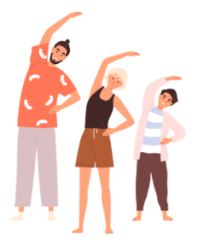
12. When was the last time you did exercise that made your heart beat faster and made you feel warmer?

☐ Within the last week
☐ Within the last month
☐ More than a month ago
☐ I don’t do any exercise

13. Why do you exercise? (Tick all that apply)


☐ To get fitter
☐ To stay healthy
☐ To get better at a sport
☐ To get stronger
☐ To manage my weight
☐ To be more flexible
☐ To feel more confident
☐ To move better
☐ To feel happier in my mind
☐ To meet people
☐ To spend time with friends
☐ I don’t do exercise
☐ Other (please say) ……………………………………………………………………………………………………………………………………………………
14. What stops you from doing more exercise? (Tick all that apply)
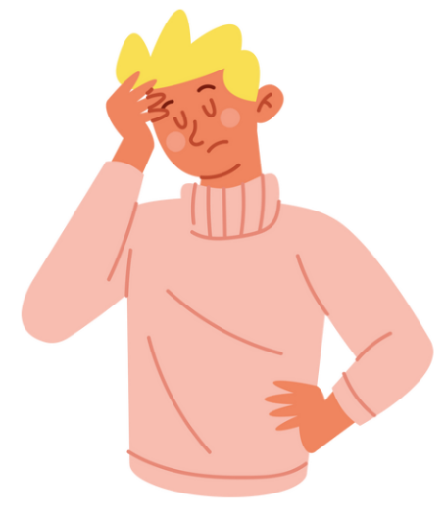
☐ Nothing — I do enough
☐ Cost (too expensive)
☐ Access (hard to get to or use)
☐ Transport problems
☐ No motivation (don’t feel like doing it)
☐ No time
☐ Don’t want to go alone
☐ Confidence (feel nervous or shy)
☐ Don’t know how to start
☐ Not fit enough to start
☐ Health problems/disability
☐ Other (please say)


15. Are you a member of any other fitness or sports clubs?

☐ Yes
☐ No

16. If yes, which ones?
……………………………………………………………………………………………………………………………………………………

17. Do you pay per visit to a leisure centre without being a member?

☐ Yes
☐ No

18. When did you last visit a leisure centre?

☐ Last week
☐ A few weeks ago
☐ A month ago
☐ A few months ago
☐ 6 months ago
☐ A year ago
☐ More than a year ago


19. If the Carlton Leisure Centre was improved (made better), would you go there more often?

☐ Yes
☐ No


20. If no, please tell us why:
………………………………………………………………………………………………………………………………

21. What would you like to see in the new leisure centre? (Pick three choices)

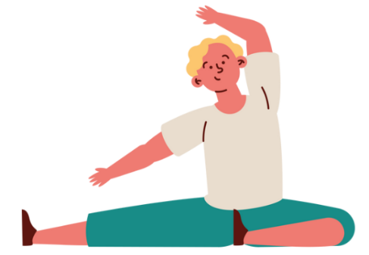
☐ Gym
☐ Group Exercise Studio (a room for group fitness classes)
☐ Group Cycling Studio (for bike fitness classes)
☐ HIIT Studio (exercise done in short, fast bursts)
☐ Health Improvement Activities (things that help you get healthier)
☐ Physiotherapy or Rehabilitation (help to move better and recover after injury)
☐ Yoga/Pilates
☐ Bowls
☐ These are not important to me
☐ Other (please say)
………………………………………………………………………………………………………………………………..

22. What swimming activities would you like? (Pick three choices)
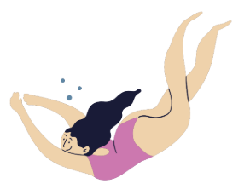
☐ Main Pool
☐ Learner Pool
☐ Family Swimming
☐ Splash Play (play area with water sprays and fun things)
☐ Sauna and Steam Room
☐ These are not important to me
☐ Other (please say)
………………………………………………………………………………………………………………………………..

23. What family activities would you like? (Pick three choices)

☐ Soft Play (safe play area for small children)
☐ Sensory Play (lights, music and activities you can feel, hear and see)
☐ Water Inflatables (big blow-up toys in the pool)
☐ Children's Parties
☐ Climbing Wall
☐ These are not important to me
☐ Other (please say)
…………………………………………………………………………………………………………………………………………………..

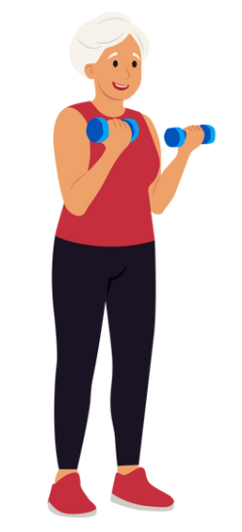
24. What activities for older people would you like? (Pick three choices)

☐ Power Assisted Equipment/Toning (machines that help you exercise gently)
☐ Water Classes
☐ Treatment Rooms (places to get massages or health care)
☐ Social Activities
☐ These are not important to me
☐ Other (please say)
…………………………………………………………………………………………………………………………………………………..

25. What community spaces would you like? (Pick three choices)
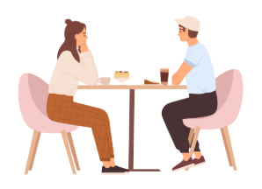
☐ Café
☐ Meeting Rooms
☐ Social Events
☐ Flexible Working Space (somewhere you can work on your laptop)
☐ These are not important to me
☐ Other (please say)
…………………………………………………………………………………………………………………………………………………..
43. What age are you?

☐ Under 16
☐ 16-24
☐ 25-34
☐ 35-44
☐ 45-54
☐ 55-64
☐ 65-74
☐ 75+

44. What is your gender?

☐ Male
☐ Female
☐ Non-binary
☐ Prefer not to say
☐ Other (please say)
…………………………………………………………………………………………………………………………………………………..


45. Do you have a health problem or disability that affects your daily life for more than 12 months?

☐ Yes
☐ No
☐ Prefer not to say

46. Are you in work?

☐ Yes — Full time
☐ Yes — Part time
☐ No
☐ Retired
☐ Other (please say)
…………………………………………………………………………………………………………………………………………………..

47. What ethnic group do you belong to?


☐ White British
☐ Irish
☐ Gypsy or Irish Traveller
☐ Any other White background
☐ White and Black Caribbean
☐ White and Black African
☐ White and Asian
☐ Any other Mixed/Multiple Ethnic background
☐ Indian
☐ Pakistani
☐ Bangladeshi
☐ Chinese
☐ Any other Asian/Asian British background
☐ African
☐ Caribbean
☐ Any other Black/Black British background
☐ Arab
☐ Other (please specify)
…………………………………………………………………………………………………………………………………………………..

48. Do you belong to a religion or faith group?


☐ Christian
☐ Muslim
☐ Buddhist
☐ Jewish
☐ Sikh
☐ Hindu
☐ I am not part of a religion or faith group
☐ Prefer not to say
☐ Other (please say)

49. Please tell us the first part of your postcode (like AB12)
…………………………………………………………………………………………………………………………………………………..


50. Would you like to join a focus group (a small chat group about leisure centres)?

☐ Yes
☐ No


51. Would you like it in person (face to face) or online?

☐ In person
☐ Online
☐ I don't mind

52. Please give your email address if you’d like to take part in a focus group:
…………………………………………………………………………………………………………………………………………………..


Thank you for taking part in our survey.

Your answers will help us to make things better at our leisure centre.

